A
Theme Based Project Report
on

Fetching Data From the Outsourced Encrypted Databases

Submitted for partial fulfilment of the requirements for the award of the degree of

BACHELOR OF ENGINEERING

in

COMPUTER SCIENCE AND ENGINEERING

By

Nagula Harini (2451-21-733-151)
Boda Jyothika (2451-21-733-153)
Athmakuri Siri (2451-21-733-159)

Under the guidance of

Mr. G.Srishailam
Assistant Professor
Department of CSE



MATURI VENKATA SUBBA RAO(MVSR) ENGINEERING COLLEGE
(An Autonomous Institution)
Department of Computer Science and Engineering
(Affiliated to Osmania University & Recognized by AICTE)
Nadergul, Balapur Mandal, Hyderabad – 501 510
Academic Year: 2022-2023

MATURI VENKATA SUBBA RAO(MVSR) ENGINEERING COLLEGE
(An Autonomous Institution)
Department of Computer Science and Engineering
(Affiliated to Osmania University & Recognized by AICTE)
Nadergul, Balapur Mandal, Hyderabad – 501 510

CERTIFICATE

This is to certify that the Theme Based project work entitled “FETCHING DATA FROM THE OUTSOURCED ENCRYPTED DATABASES” is a bonafide work carried out by Nagula Harini(2451-21-733-151), Boda Jyothika(2451-21-733-153), Athmakuri Siri(2451-21-733-159) in partial fulfilment of the requirements for the award of degree of Bachelor of Engineering in Computer Science and Engineering from Maturi Venkata Subba Rao(MVSR) Engineering College, affiliated to OSMANIA UNIVERSITY, Hyderabad, during the Academic Year 2022-2023. under our guidance and supervision.

The results embodied in this report have not been submitted to any other university or institute for the award of any degree or diploma.

Internal Guide Head of the Department
Mr G.Srishailam Prof J Prasanna kumar
Assistant Professor Professor & Head
Department of CSE Department of CSE
MVSREC. MVSREC.

DECLARATION

This is to certify that the work reported in the present Theme Based project entitled “FETCHING DATA FROM THE OUTSOURCED ENCRYPTED DATABASES” is a record of bonafide work done by us in the Department of Computer Science and Engineering, M.V.S.R. Engineering College, Osmania University. The reports are based on the work done entirely by us and not copied from any other source.
The results embodied in this report have not been submitted to any other University or Institute for the award of any degree or diploma to the best of our knowledge and belief.

Nagula Harini Boda Jyothika Athmakuri Siri
(2451-21-733-151) (2451-21-733-153) (2451-21-733-159)

ACKNOWLEDGEMENT

We would like to express our sincere gratitude and indebtedness to our project guide Mr.G.Srishailam, Assistant Professor for his valuable suggestions and interest throughout the course of this project.
We are also thankful to our principal Dr. G. Kanaka Durga and Prof. J Prasanna Kumar, Professor and Head, Department of Computer Science and Engineering, MVSR Engineering College, Hyderabad for providing excellent infrastructure and a nice atmosphere for completing this project successfully as a part of our B.E. Degree (CSE).
We convey our heartfelt thanks to the lab staff for allowing us to use the required equipment whenever needed.
Finally, we would like to take this opportunity to thank our family for their support through the work. We sincerely acknowledge and thank all those who gave directly or indirectly their support in completion of this work.

Nagula Harini (2451-21-733-151)
Boda Jyothika (2451-21-733-153)
Athmakuri Siri (2451-21-733-159)

DEPARTMENT OF COMPUTER SCIENCE & ENGINEERING

VISION
To impart technical education of the highest standards, producing competent and confident engineers with an ability to use computer science knowledge to solve societal problems.

MISSION
To make the learning process exciting, stimulating and interesting.
To impart adequate fundamental knowledge and soft skills to students.
To expose students to advanced computer technologies in order to excel in engineering practices by bringing out the creativity in students.
To develop economically feasible and socially acceptable software.

PROGRAM EDUCATIONAL OBJECTIVES (PEOs)

The Bachelor’s program in Computer Science and Engineering is aimed at preparing graduates who will :-
PEO-1: Achieve recognition through demonstration of technical competence for successful execution of software projects to meet customer business objectives.

PEO-2: Practice life-long learning by pursuing professional certifications, higher education or research in the emerging areas of information processing and intelligent systems at a global level.

PEO-3: Contribute to society by understanding the impact of computing using a multidisciplinary and ethical approach.

Program Specific Outcomes (PSOs)

PSO1: Demonstrate competence to build effective solutions for computational real-world problems using software and hardware across multi-disciplinary domains.

PSO2: Adapt to current computing trends for meeting the industrial and societal needs through a holistic professional development leading to pioneering careers or entrepreneurship.

COURSE OBJECTIVES AND OUTCOMES

Course Objectives

- To enhance practical and professional skills.
- To familiarize tools and techniques of systematic literature survey and documentation.
- To expose the students to industry practices and teamwork.
- To encourage students to work with innovative and entrepreneurial ideas.

Course Outcomes

- Demonstrate the ability to synthesize and apply the knowledge and skills acquired in the academic program to the real world problems.
- Evaluate different solutions based on economic and technical feasibility
- Effectively plan a project and confidently perform all aspects of project management.
- Demonstrate effective coding, written, presentation and oral communication

ABSTRACT

Recently, database users have begun to use cloud database services to outsource their databases. The reason for this is the high computation speed and the huge storage capacity that cloud owners provide at low prices. However, despite the attractiveness of the cloud computing environment to database users, privacy issues remain a cause for concern for database owners since data access is out of their control.

Encryption is the only way of assuaging users’ fears surrounding data privacy, but executing Structured Query Language (SQL) queries over encrypted data is a challenging task, especially if the data are encrypted by a randomized encryption algorithm. Many researchers have addressed the privacy issues by encrypting the
data using deterministic, onion layer, or homomorphic encryption.

Nevertheless, even with these systems, the encrypted data can still be subjected to attack. In this research, we first propose an indexing scheme to encode the original table’s tuples into bit vectors (BVs) prior to the encryption. The resulting index is
then used to narrow the range of retrieved encrypted records from the cloud to a small set of records that are candidates for the user’s query. Based on the indexing scheme, we then design a system to execute SQL queries over the encrypted data.

The data are encrypted by a single randomized encryption algorithm. In the proposed scheme, we store the index values (BVs) at user’s side, and we extend the system to support most of relational algebra operators, such as select, join, etc. Implementation and evaluation of the proposed system reveals that it is practical and efficient at reducing both the computation and space overhead.

Nagula Harini(2451-21-733-151)

Boda Jyothika(2451-21-733-153)
Athmakuri Siri(2451-21-733-159)
TABLE OF CONTENTS

Title Page 1
Certificate 2
Declaration 3
Acknowledgement 4
Vision, Mission, Program Outcomes, Program Specific Outcomes 5
Course Objectives and Outcomes 6
Abstract 7

INDEX

1.INTRODUCTION 9
1.1 PROBLEM STATEMENT
1.2 OBJECTIVE
1.3 SCOPE

2.SYSTEM REQUIREMENT SPECIFICATIONS 10
2.1 SOFTWARE REQUIREMENTS
2.2 HARDWARE REQUIREMENTS

3.TOOL USED 11-12

4.IMPLEMENTATION 13-19

5.RESULT 20-21

6.CONCLUSION 22

REFERENCES 23

1.INTRODUCTION

  - Problem Statement

Theft of private information is a significant problem, particularly for online applications. An adversary can exploit software vulnerabilities to gain unauthorized access to servers, curious or malicious administrators at a hosting or application provider can snoop on private data and attackers with physical access to servers can access all data on disk and in memory . One approach to reduce the damage caused by server compromises is to encrypt sensitive data, and run all computations (application logic) on clients. Unfortunately, several important applications do not lend themselves to this approach, including database-backed web sites that process queries to generate data for the user, and applications

  - Objectives

- To Fetch Data from the Outsourced Encrypted Databases.
- To Secure the data from the external hosts.
- To Encrypt the data in a way that no outsider can access the data.

  - Scope

The presented system helps the user in

- Data Confidentiality
- Data Integrity
- Data Authentication
- Data Non-Repudiation

2.SYSTEM REQUIREMENT SPECIFICATIONS

  - Software requirements

Linux OS
Linux is an open-source operating system like other operating systems such as Microsoft Windows, Apple Mac OS, iOS, Google android , etc. An operating system is a software that enables the communication between hardware and software. It conveys input to get processed by the processor and brings output to the hardware

VM VirtualBox
Oracle VM VirtualBox is a cross-platform virtualization software. It allows users to extend their existing computer to run multiple operating systems including Microsoft Windows, Mac OS X, Linux, and Oracle Solaries, at the same time

  - Hardware requirements

- A Laptop with 8GB RAM

- Internet Connection to set up the software

3.TOOL USED

CryptDB

- CryptDB was built for tested and practical security in the case of corrupted databases or motivated database managers.

- CryptDB utilizes authenticated details when running SQL queries. The SQL-aware encryption technology primarily includes the task of mapping SQL operations with the support of encryption techniques, which enables CryptDB to adjust the encrypted data level according to user requests and to effectively modify the data by layered encryption rates.

- CryptDB simply allows the application to perform queries submitted by users and guarantees full anonymity given the mixture of users’ queries. The database server completely evaluates the encrypted data queries and returns the results back to the client to be decrypted for penultimate purposes.

- CryptDB ensures that clients do not process queries and client-side applications operate unchanged.

- CryptDB is a system that provides practical and provable confidentiality in the face of these attacks for applications backed by SQL databases.

- It works by executing SQL queries over encrypted data using a collection of efficient SQL-aware encryption schemes

- CryptDB can also chain encryption keys to user passwords, so that a data item can be decrypted only by using the password of one of the users with access to that data

Features of CryptDB

The main features of cryptDB are listed below :

• They use strong encryption methods
• There are several query types applicable, since various kinds of encryption techniques and application modifications are used.
• It is fast. It stems from the analysis of the actual phpBB, HotCRP and gradation trials.
• A complex technique for transmitting specific data sets to various users is supported by layered encryption schema.

Limitations of CryptDB

CryptDB has some theoretical limitations as identified below:

• High vulnerability is implicit in user data.
• Cryptographic key protection is overhead for the whole framework.
• Intensive computations are used to encrypt a query.
• It does not suffice to use a single encryption method., therefore, it increases the overhead.
• CryptDB often leaks data, helping attackers learn the interface, which will eventually allow them to interfere with user data.

4.IMPLEMENTATION

Step1: setup VM VirtualBox
Step2: run the VirtualBox
Step3: start the Oracle VM VirtualBox
Step4: Open a terminal
Step5: enter the below command in the terminal

export EDBDIR=/home/osboxes/cryptdb/

Step6: Run it

Step7: enter the below commands

/home/osboxes/cryptdb/bins/proxy-bin/bin/mysql-proxy --plugins=proxy --event-threads=4 --max-open-files=1024 --proxy-lua-script=$EDBDIR/mysqlproxy/wrapper.lua –proxy-address=127.0.0.1:3307 --proxy-backend-addresses=localhost:3306

mysql -u root -pwelcome -h 127.0.0.1 -P 3307

Step8: Run it

SQL server will be opened

Step9: enter the command

show databases;

Step10: Run MySQL

The below shown fig(1) will be the output:

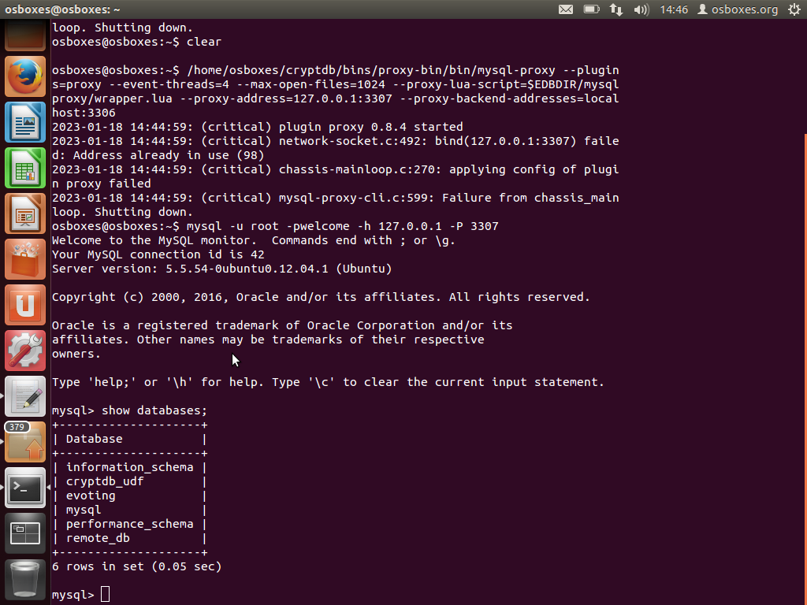
Fig(1)

Step11: fetch the data from the ‘evoting’ database, use the command

use evoting;

This command helps to change the database

Step12: fetch the tables from the ‘evoting’ database, use the command

show tables;

The above command display all the tables in the ‘evoting’ database as shown in fig(2)

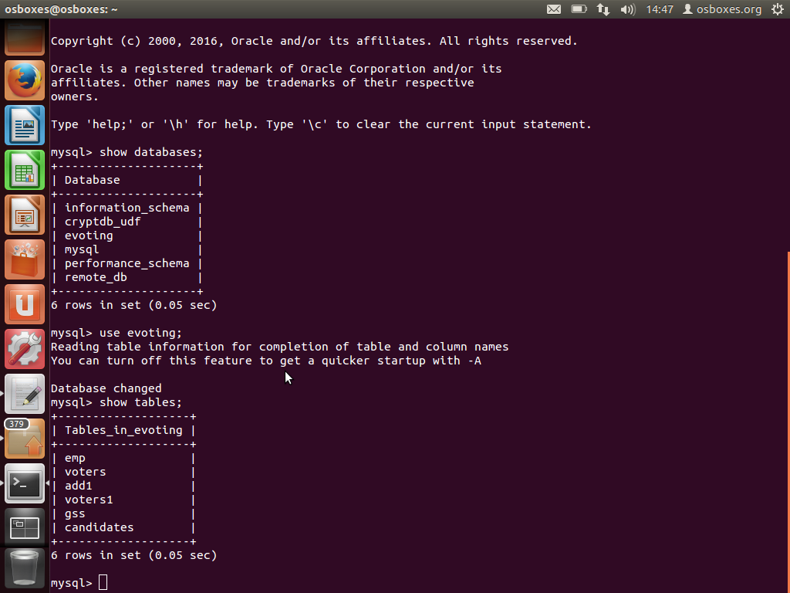
Fig(2)

Step13: fetch the data of ‘voters’ table, use the command

select * from voters;

The output will be the data of the voters table from ‘evoting’ database as shown in fig(3)
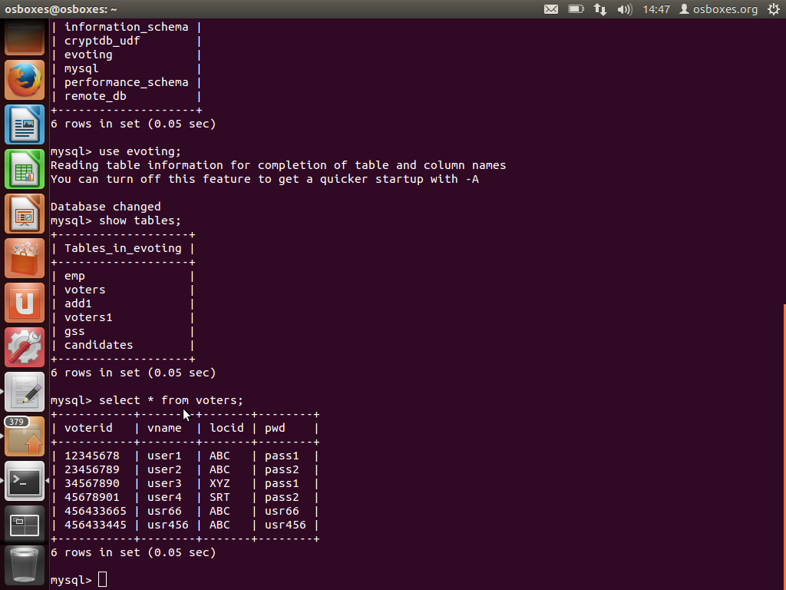
Fig(3)

The data is accessed, the encrypted data which was created i.e, the admin(user 3307) is the user ,So the data is fetched here without any encryption…
see the way the data gets encrypted when it is accessed by an external user (user 3306).

Step14: Open another terminal
Step15: Use the command

mysql -u root -pwelcome -h 127.0.0.1 -p 3306

This command opens the MySQL server for user 3306

Step16: To access the databases present in the MySQL server from 3306 user, use the below command to display the databases

show databases;

The output will be as follows as fig(4)

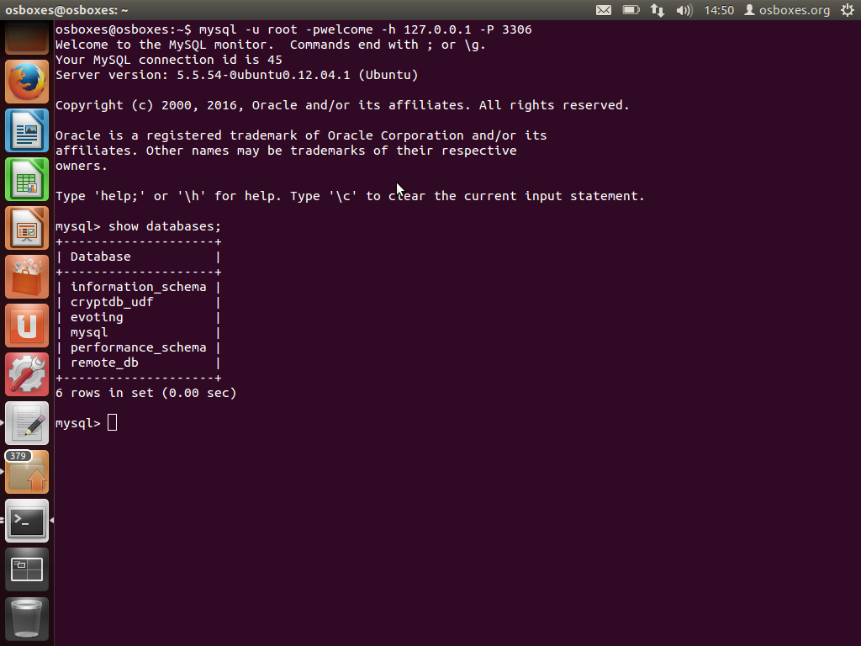
Fig(4)

Step17: fetch the data from the ‘evoting’ database, use the command

use evoting;

This command helps us to change the database fig(5)
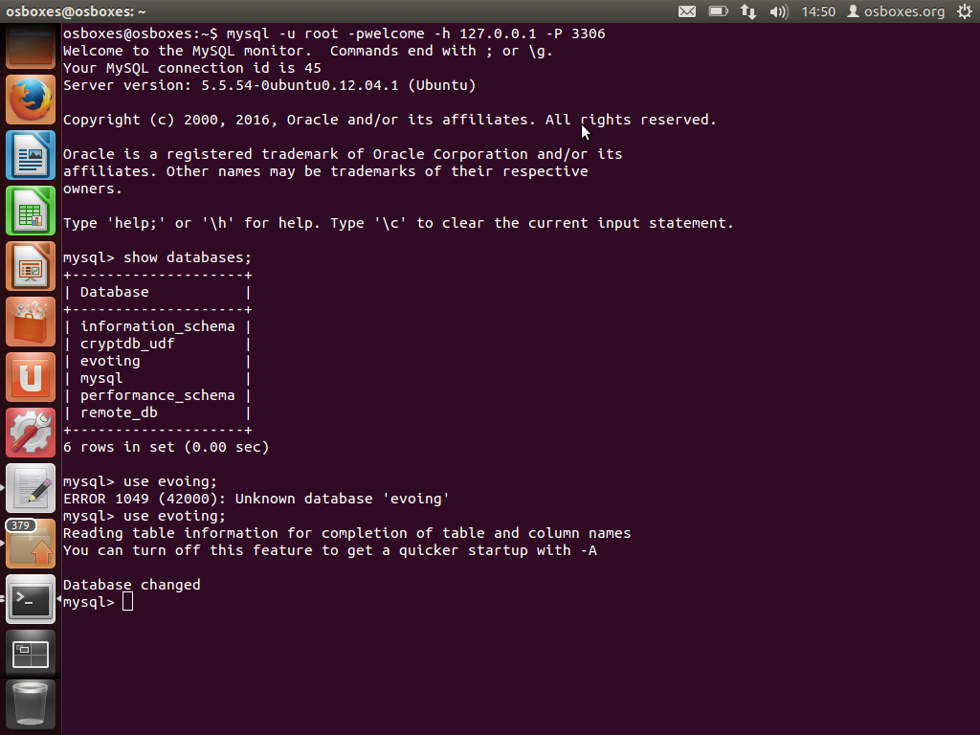
Fig(5)

Step18: fetch the tables from the ‘evoting ‘database, use the command

Show tables;

The output will be as follows fig(6);
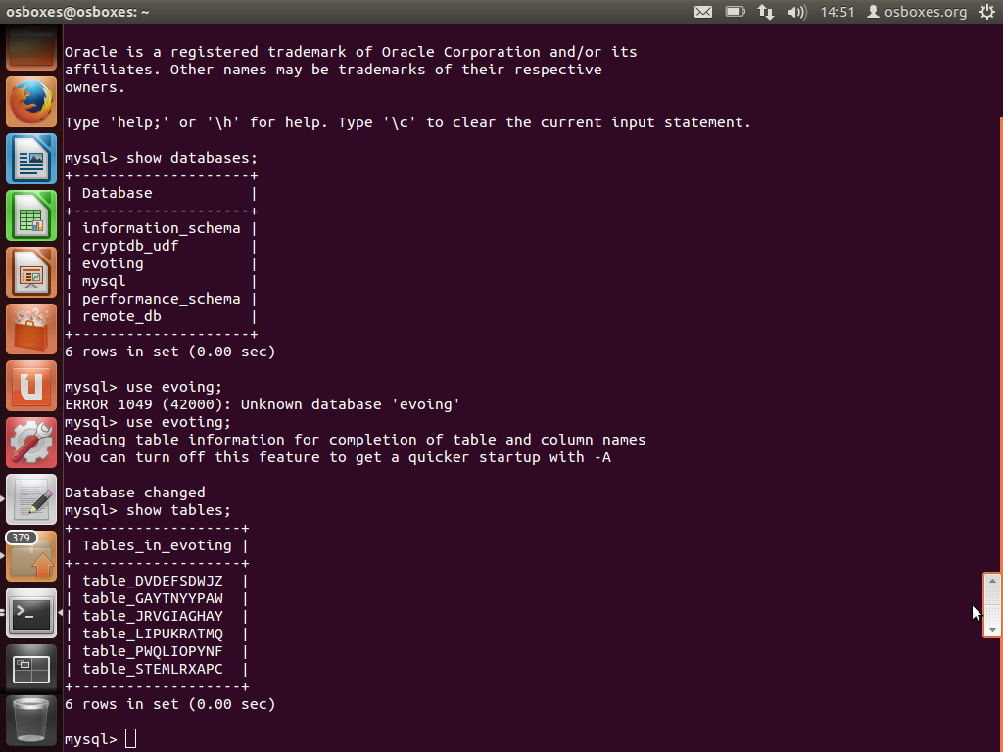
Fig(6)

It is observed that the list of tables shown are some random codes

These are the encrypted form of the data

5.RESULT

When admin try to access the data as user 3307(admin) the data is displayed in the general form ...i.e without any encryption as user(3307) is the admins, but when the external user(3306) try to access the data, the data is displayed in the encrypted form.

Step19: fetch the data of those encrypted tables, Use the command

select * from (any of the encrypted table);

The output will be as follows fig(7)

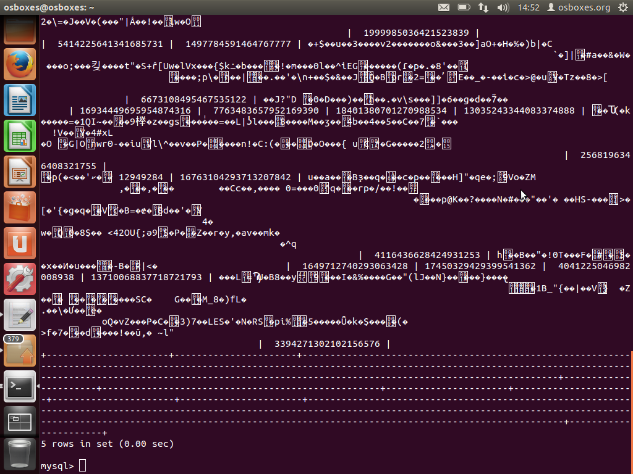
Fig(7)

From the fig(7) it’s concluded that when some external user try to access the data from the encrypted databases of cyptDB ,the data will be fetched in encrypted form.

This give the idea of how cryptDB secures the encrypted data when some external users or cyber attackers try to access them.

6.CONCLUSION

CryptDB, a system that provides a practical and strong level of confidentiality in the face of two significant threats confronting database-backed applications: curious DBAs and arbitrary compromises of the application server and the DBMS. CryptDB meets its goals using three ideas: running queries efficiently over encrypted data using a novel SQL-aware encryption strategy, dynamically adjusting the encryption level using onions of encryption to minimize the information revealed to the untrusted DBMS server, and chaining encryption keys to user passwords in a way that allows only authorized users to gain access to encrypted data

REFERENCES

- CryptDB: Protecting Confidentiality with Encrypted Query Processing Raluca Ada Popa, Catherine M. S. Redfield, Nickolai Zeldovich, and Hari Balakrishnan MIT CSAIL

- A SYSTEMATIC REVIEW OF CRYPTDB: IMPLEMENTATION, CHALLENGES, AND FUTURE OPPORTUNITIES Hana Yousuf, The British University in Dubai Said A. Salloum, University of Salford, University of Sharjah Ahmad Aburayya, Dubai Health Authority Mostafa Al-Emran, The British University in Dubai Khaled Shaalan, The British University in Dubai

- Encrypted Databases: From Theory to Systems Zheguang Zhao∗ Brown University Seny Kamara† Brown University Tarik Moataz‡ Aroki Systems Stan Zdonik§ Brown University

- An Efficient Secure System for Fetching Data From the Outsourced Encrypted Databases SULTAN ALMAKDI 1 , BRAJENDRA PANDA2 , (Senior Member, IEEE), MOHAMMED S. ALSHEHRI 1 , (Graduate Student Member, IEEE), AND ABDULWAHAB ALAZEB 1,2, (Graduate Student Member, IEEE) 1Department of Computer Science, College of Computer Science and Information systems, Najran University, Najran 55461, Saudi Arabia 2Department of Computer Science and Computer Engineering, University of Arkansas, Fayetteville, AR 72701, USA Corresponding author: Sultan Almakdi (saalmakdi@nu.edu.sa)

